# Schaltnetze

## A1 Negierte Negation

z = ¬(a ∨ ¬b)

|  |  |  |
| --- | --- | --- |
| a | b | z |
| 0 | 0 | 0 |
| 0 | 1 | 1 |
| 1 | 0 | 0 |
| 1 | 1 | 0 |

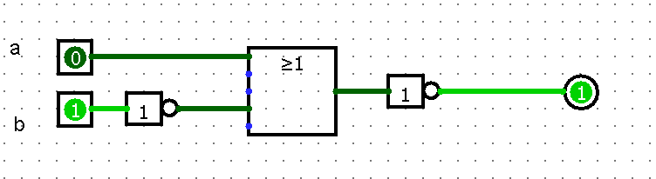

## A2 Triple-AND

z = (a ∧ b) ∧ c

y = a ∧ (b ∧ c)

|  |  |  |  |  |
| --- | --- | --- | --- | --- |
| a | b | c | z | y |
| 0 | 0 | 0 | 0 | 0 |
| 0 | 0 | 1 | 0 | 0 |
| 0 | 1 | 0 | 0 | 0 |
| 0 | 1 | 1 | 0 | 0 |
| 1 | 0 | 0 | 0 | 0 |
| 1 | 0 | 1 | 0 | 0 |
| 1 | 1 | 0 | 0 | 0 |
| 1 | 1 | 1 | 1 | 1 |

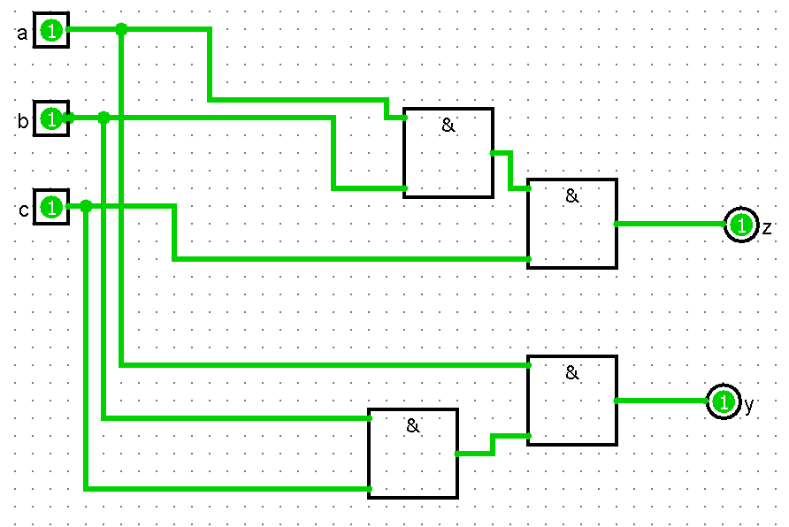

## A3 GE-UND-ETES OR

z = (a ∨ c) ∧ (a ∨ b)

|  |  |  |  |
| --- | --- | --- | --- |
| a | b | c | x |
| 0 | 0 | 0 | 0 |
| 0 | 0 | 1 | 0 |
| 0 | 1 | 0 | 0 |
| 0 | 1 | 1 | 1 |
| 1 | 0 | 0 | 1 |
| 1 | 0 | 1 | 1 |
| 1 | 1 | 0 | 1 |
| 1 | 1 | 1 | 1 |

